Date: ____________________________

Dear Parents:

During the 2015-2016 school year, Intermediate Unit 1 will provide the Hand In Hand program, a social group for students who are Deaf/Hearing impaired. The Hand In Hand program will occur at the Intermediate Unit 1 Central Office located at One Intermediate Unit Drive, Coal Center, PA on Friday’s, **October 16, 2015, March 18, 2016, and May 13, 2016**. The students will leave their home districts approximately at 9:00 am and return before their regular dismissal.

The Teacher of the Deaf/Hearing Impaired will provide direct supervision, and the Intermediate Unit 1 will provide transportation.

It is necessary to have your written permission for your child to be transported outside the school setting on these dates. Please complete and return the bottom of this letter to their teacher as soon as possible.

If you have any questions, please feel free to call me at (724) 938-3241 ext 302.

Sincerely,

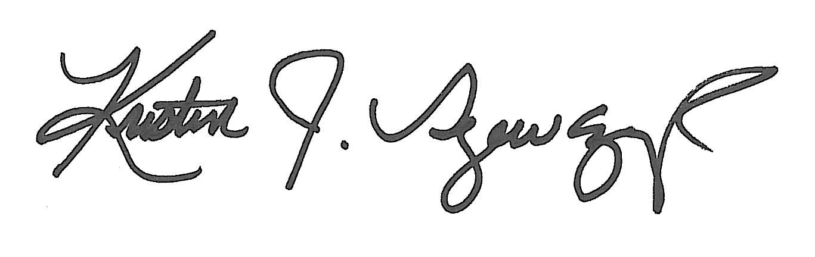

Kristin J. Szewczyk, Ed. D./CCC-SLP, CBIS

Supervisor of Special Education

Communication Disorders and Sensory Impairments Program

Permission for Hand In Hand Program 2015-2016

___ I give permission to Intermediate Unit 1 to transport my child, ______________________, to and from the Hand In Hand Program for the 2015-2016 school year. I understand that he/she will be off school grounds under the supervision of the Teacher of the Deaf/Hearing Impaired.

**_____ October 16, 2015 _____ March 18, 2016 _____ May 13, 2016**

___ I do not give permission to Intermediate Unit 1 to transport my child to and from Hand In Hand Program for the school year.

____________________________________ __________________

Signature of Parent/Guardian Date